**Dynamic Governance Intro and Roadmap**

**TL;DR:** I think dynamic governance is great model to facilitate collaboration between diverse stakeholders and as such would be great for DCE board-level decision-making, and for emerging collaborative projects. It also offers potential for employee-level governance and management. Rebekah, Jeff, and I are attending a conference and some facilitator training. Then we want to run pilots internally. If successful, we then want to run a collaborative project pilot.

**Introduction**

Dynamic governance is an attempt to fuse the efficiency of hierarchical structures and the inclusivity of horizontal ones in a consent and purpose-driven governance model. Components of sociocracy should work well within our existing DCE framework at the board level, for collaborative projects, and for employee-level governance. To explain how, I will first give a short summary of dynamic governance. I will then provide a brief overview of how this model – or concepts from it – might be leveraged in the employee stakeholder group, in collaborative projects, and in DCE/board-level governance. Finally, I will provide a proposed education, piloting, and implementation roadmap.

**Summary of Influential Dynamic Governance Principals**

There are **three essential principals** to dynamic governance: consent, circles, and double-linking.

*Consent-based decision-*making is contrasted with the concept of “consensus”; rather than require everyone to come to agreement about a decision, consent requires only that no one has a reasoned “not over my dead body” objection. Democracy does not emphasize consent in this way, nor does autocratic or strictly hierarchical rule.

*Circles:* In a dynamic governance model, day-to-day operations are done according to familiar hierarchies (there are managers, and those who are managed), but policy-level decisions are made together.

The image below is taken from [a slide](https://www.youtube.com/watch?v=F818QTn6_f8&feature=youtu.be) here.

[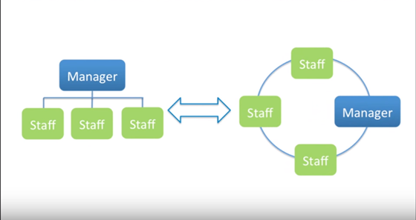](https://user-images.githubusercontent.com/41302870/56592415-7e9dff80-659f-11e9-95d6-2c2fdd0f87f6.png)

In this structure, there are a series of circles extending up the hierarchy, like pictured below. In this way, circles are a fusion of top-down and democratic decision-making.

[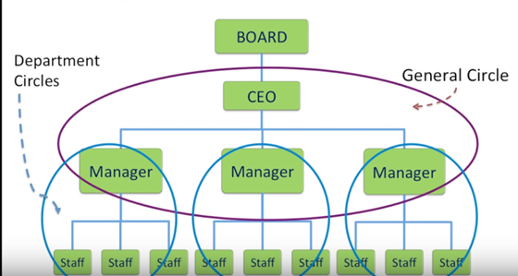](https://user-images.githubusercontent.com/41302870/56592463-9ecdbe80-659f-11e9-9183-85066ee3621b.png)

Policies may be crafted in the circle or derived elsewhere and decided in the circle. The process by which a circle would propose a policy together is listed below. Fewer steps would be required early on if the proposal were drafted separately, but then you risk not building in consideration of people’s concerns ahead of time, potentially requiring multiple drafts to reach consent. This method also works for electing circle representatives or facilitators.

1. State the purpose of the organization, and of this particular circle (ex: Blockchains’ purpose and the goal of the project).
2. State the problem needing solved. (ex: We have two research facilities. What should be done where?)
3. As a team, in no particular order, identify the complexity/dimensions of the issue. (ex: Both parties want to boost their lab’s reputation, one might have more funding or more appropriate researchers for certain components, there might be limited facility hours, etc.)
4. Consent to list of dimensions – Does this list include all of the necessary components for consideration? – every individual speaks.
5. As a team, in no particular order, troubleshoot possible solutions to the concerns/brainstorm policy solutions (e.g., certain components of research can be done in each facility; one facility can be used early on, while the other one will be used later; agree that all relevant documentation credits the project as a collaborative partnership; some researchers from one facility work in the other group’s facility; etc.)
6. As a group, or by way of delegate (or volunteer), draft one or more proposals attempting to address the concerns raised.
7. Present proposal(s)
   1. Clarifying question round. Every individual has opportunity to speak, one at a time.
   2. Quick reaction round. Every individual has opportunity to speak, one at a time.
8. As long as everyone consents (doesn’t have to love it – just be okay with it), it’s adopted.
9. If there are reasonable objections, address them. Retry.

Double-links: Every circle has elected representation in the circle above it (separate from the person/s occupying the highest position in the hierarchy, who is necessarily already in the higher circle). This is intended to create more continuity across the organization. It helps ensure transparency and enable communication from top to bottom. It also allows for individuals from a lower rank in the organization to be elected all the way to the top circle because every individual in every circle is equal within that circle. However, it gets complicated when you have a lot of people in middle management reporting to the same person (e.g., if six managers report to one VP, there would be a 13-person circle around that VP), or a complicated org chart– though in the latter case you could just get creative with your circles.

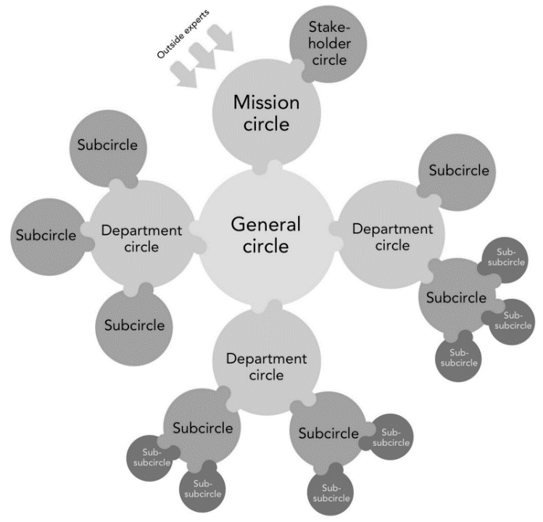 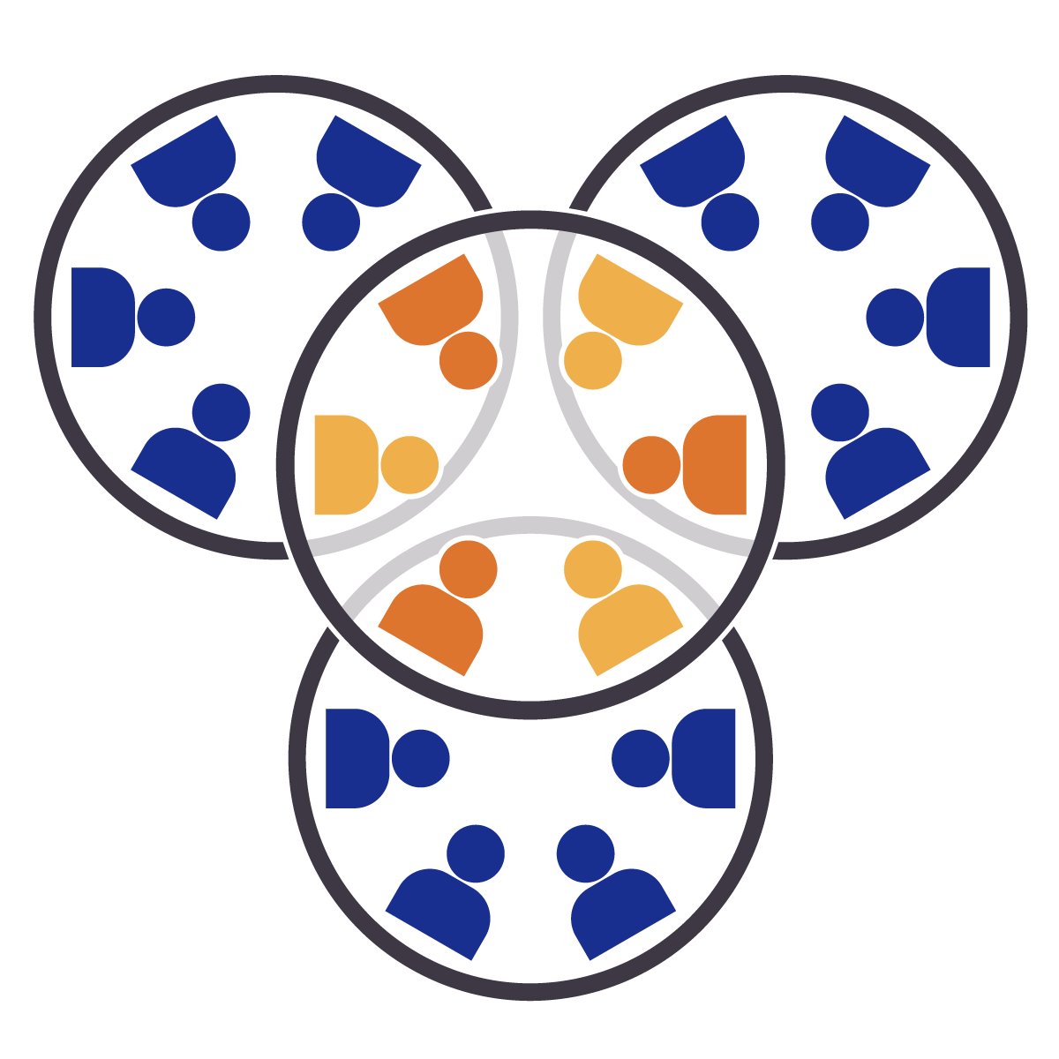

**Sociocracy, as Applied to Blockchains’ Governance Needs: A Brief Explanation**

**Employee stakeholder group:**

dynamic governance would enable the efficiency in day-to-day workflow and clear expectations for employees offered by hierarchical and worker-self management, while allowing for the empowerment of the individual worker in higher level goal-setting and decision-making. This is not dissimilar to [Netflix’s](https://jobs.netflix.com/culture) “highly aligned; loosely coupled” approach. Dynamic governance also enables transparency and communication across an organization – something that can be challenging in both decentralized/horizontal organizations and in hierarchical ones.

***Reputation***

The model also integrates with the organizational structure created by Colony’s domain-based decision-making software. Domains would likely constitute circles, though it might also make sense to include multiple subdomains in certain circles.

Colony’s model is reputation-driven democratic voting, whereas dynamic governance is not voting-based and considers every individual to be equal. Each may be useful in different contexts.

Reputation can do at least three things. First, it gives individuals who contribute more to an organization more power within it. Second, reputation functions as a “proof of identity.” Third, it can be used as a metric for decisions about promoting or terminating staff.

Reputation-based voting may be helpful because it allows for expression of the larger organization’s preferences when decisions are being made in a higher-level domain. For example, if the board wants to make some decision, they might have reputation-holding stakeholders vote on it – whether as a binding decision or as a signaling strategy. Electing board representatives, adding or removing stakeholder groups, and issuing new stock are some examples where stakeholder-wide elections are necessary, and where reputation-weighted votes are useful. Reputation-based voting is also useful in situations where double-linking would create an unwieldly circle. Rather than double-linking, a circle’s proposal may be considered by reputation holders in the lower domain. There’s a lot more to say in this area, but for the scope of this proposal, suffice it to say that dynamic governance and reputation-based voting, though incongruent, may be effectively used together in Blockchains’ organizational governance and management.

***Collaborative Projects****:*

Dynamic governance seems to be well-suited to accommodating the diverse interests, personalities, and perspectives involved in these ventures. Consider, for example, the diversity of players in the emerging hemp collaboration. The hemp collaboration unites stakeholders coming to the table with varying interests, skills, personalities, and resources. This diversity offers the potential for truly meaningful and wide-reaching research and innovation, but also comes with the potential for conflict. Dynamic governance encourages collaboration, emphasizes consent, and allows for equal inclusion of all voices and perspectives in the decision-making process, minimizing the risk for conflict to damage outcomes.

A partial implementation makes the most sense for these projects, since we do not desire to dictate the governance or management of outside entities.

*Circle Governance and Consent:* We should borrow circle and consent-based decision making at the highest level of collaboration, where we will be present and therefore able to facilitate the circle, and observe it. Any subcommittee of which we are a part should also operate in this way, but we are silent on the organization of other committees or action-groups.

*Double-Linking:* Blockchains will abide by the double-link rule, but we do not ask or expect other collaborative entities to do the same.

**Board-Level:**

The board should work well using the dynamic governance framework, for the same reasons in in much of the same ways as the collaborative projects.

The board is comprised of representatives from each stakeholder group (the person with the highest position in that group, or an elected representative, depending on the nature of the stakeholder group), and some people who are non-stakeholder group specific, as elected in a stakeholder-wide vote. In a sense, the stakeholder-wide elected representatives function similarly to the double-link concept – at least insofar as they are trusted individuals chosen by the larger DCE, who are therefore beholden to the stakeholders (the circles below), and not solely the individuals on the board (the circle they’re acting in). All board members are equal and consent must be reached within committees (read: circles) prior to reaching board-wide vote. Committees are open. Roles within committees and on the board, if contested between two or more parties, should be subject to the consent circle. President, secretary and treasurer included.

Like the collaborative projects implementation, we are silent on the governance of stakeholder groups/collaborative partners who operate independently of Blockchains.

**Roadmap:**

**May 2:** webinar conference. 20+ organizations tell their stories of using sociocracy

**May 8-22nd:** Facilitator training

(**week of the 15th**) Present to execs the model and roadmap

Finalize rollout plans

**June 1:** Piloting begins**:** Content and communications, CLD